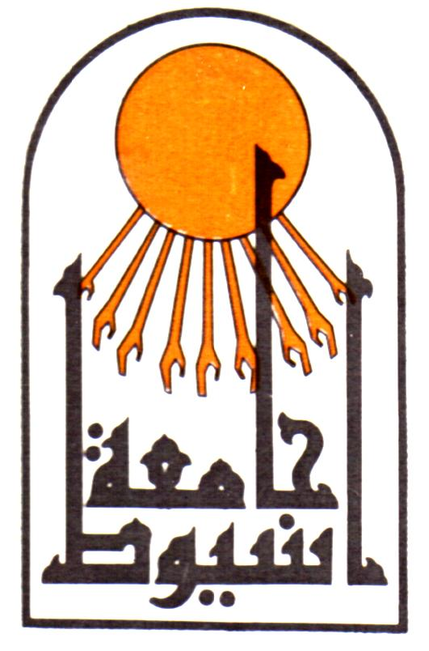

Assiut University
Faculty of Medicine
Dept. of Radiodiagnosis

CURRICULUM VITAE

Marwa Makboul Ahmed Makboul
Assistant lecturer of Radiodiagnosis,
Assiut University Hospital,
Assiut, Egypt
Tel : Home (+2088) 2186058
Office:(+2088)2413140
Fax : (+2088)(2333327)
Mobile: (+2)01006541595
E-Mail: drmarwa201198@ymail.com

Personal data |  | First name : Marwa  Middle name :Makboul  Last name (Family or Surname): Ahmed  Tel: Home : +2 088 2186058  Hospital : +2 0882413140  Mobile : +201006541595  Fax : +2 088 2333327  Email : drmarwa201198@ymail.com  Date of birth :1, September, 1982.  Marital status : Married.  Nationality : Egyptian.  Address : Egypt, Assiut 98 Takseem Elhokokyeen  Correspondence: Egypt, Assiut, Assiut University Hospital,  Department of Radiodiagnosis.  Current hospital: Department of Radiodiagnosis, Assiut  University Hospital, Assiut, Egypt.  Languages : Arabic and English.
Current position |  | Assistant lecturer of Radiodiagnosis, Assiut University Hospital, Assiut, Egypt (23/1/2011 till now).
Positions held |  | House officer: Assiut University Hospital (1/3/2006-28/2/2007).  Resident (Radiodiagnosis): Assiut University Hospital (1/3/2007-28/2/2010).
Qualifications |  | High school diploma (basic education): Khadega Yousef High School, Assiut, Egypt (1997-1999).  MB.Bch: Faculty of medicine, Assiut University (9/1999-9/2005) (Excellent). [1]  M.Sc. in Radiodiagnosis: Assiut University Hospital (22/4/2007-10/11/2009). [2]
Clinical Experience | During my work as a house officer, as a resident and as an assistant lecturer, I gained experience in the following activities:  - Ultrasounds, MRIs, CT scans, X-ray imaging, portable radiography and fluoroscopic procedures.  - Prepared patients for radiology examinations and explained procedures to patients  -Positioned radiographic equipment at correct angle/height  - Assisted with administering radiographic exams and film development  - Operated all major, necessary and portable diagnostic imaging equipment  - Experience with digital radiography  - Performed imaging procedures of the Diagnostic Imaging Department  - Assisted in x-ray examination, and diagnosis of injury/disease observation  -Emergency interventional procedures as  Ultrasound-guided Hydrostatic Reduction of Childhood Intussusception  -Elective interventional procedures, including:  Ultrasound-guided percutaneous drainage of abdominal abscess.  Ultrasound-guided biopsy
Graduate, post graduate training, courses and conferences attended | 1999-2005: Graduate studies; Faculty of medicine, Assiut University.  2006-2007: House officer; Assiut University Hospital.  2007-2010: Resident; Radiodiagnosis dept., Assiut University Hospital.  18-20/ 5/ 2010: The 40th Annual conference for the Egyptian Society of Radiology & nuclear medicine , Cairo, Egypt.  1-2/6/2011: The Annual meeting of the Egyptain Society of Liver Cancer, Cairo, Egypt.  31th Oct-2nd Nov The 45th Annual conference for the Egyptian Society of Radiology & nuclear medicine , Cairo, Egypt.
Teaching activities | Supervising house officers since March, 2007.  Supervising the work of residents since December, 2009.  Involved in undergraduate student teaching since January, 2011.
Research activities | -Role of multidetector computed tomography (MSCT) in diagnosis of biliary tract obstruction. Egyptian Radiology Annual J 2012; 3: 212-5.  - Role of proton magnetic resonance spectroscopy and diffusion weigted imaging on characterizing benign and malignant breast lesion. Accepted as electronic poster in European Congress of Radiology (ECR)7-11 March, 2013.
Referees and references | [1] Assiut University was inaugurated in 1957 to encourage research, education and community services in Upper Egypt. It is located in Assiut City which is 375 Km south of Cairo, the capital. The university comprises sixteen faculties and two higher institutions. PO Code No. 71515, Egypt. http://www.aun.edu.eg  [2] Assiut University Hospital is one of the biggest University Hospitals in Egypt. It is the core referral center for the whole Upper Egypt that serves about twenty million people. The hospital contains 2027 beds, including 94 ICU beds, and 46 operative theaters in which 240 operations are performed daily. 1478 medical and 6428 paramedical staff serve in this hospital. 3000 patients visit the outpatient clinics and 1000 are received in the emergency unit daily. http://www.aun.edu.eg/fac_med/medicin/Hospital2.htm  [3] Hisham Mostafa Kamel Emam; Professor of radiodiagnosis, Assiut university hospital. Assiut , Egypt, hishamimam62@hotmail.com.

